Gabriel Coto, Nicholas Miller, Phillip Taylor

Dr. Shankar and Professor McAfee

EGN 1935

29 June 2015

Global Outreach Final Report

**Abstract**

*After a two-week introductory period in learning the basics of App development, and a one-week period to generate an idea for an original application and develop it, our group has produced the application Global Outreach. The application was designed to provide an efficient and convenient way for people of all ages to connect by creating or attending events themed towards community service, environmental projects, charity, and non-profit work. This paper will discuss the intended purpose of Global Outreach, the functionality of the application, the process our group took in creating our application, the features we were unable to implement given the short development time, and our ideas for improving the original idea of the app. As a general overview of our application, Global Outreach currently has six activities, one consisting of item fragments, and another opening a camera, our sensor; all activities and their purposes will be discussed in further detail in the paper.*

*Since our group was unable to get the camera sensor to function properly in processing, with permission, the camera sensor was implemented in android studio, and from there into our application. In addition to this sensor, our application takes advantage of java code to specify the activities by the buttons selected, to add login specifications, to store information about in the event create activity such as the spinners incorporated, and to create fragments for the my events activity (in development). The graphics were integrated into our application in every activity, used to create a unique style and color scheme. The button's, background, app logo and icon, and about screen were all implemented graphical features. The xml code was used to format the integrated graphics and java code for every activity.*

*There were many original ideas not implemented into the application, the primary one being the my events activity, and much of the original plan to code for storing input for the create events activity was not implemented due to time constraints. Looking forward, we would like to improve this application by finishing all features we were unable to implement, and go beyond by using google maps, and creating servers that will allow interactions between devices on a much wider scale.*

**Background**

Global Outreach is an app designed to facilitate the planning, sharing and coordinating of events for community service, charity and environmental conservation. Using the ‘create event’ button, users can set up an entire event from just one screen on their phone. Events can be given details like date, time, cost, address, age requirements, description, organization name, and contact info. Users can choose from different types of events like environmental or charity. Themes like food, education, family, sports and music can also be chosen for the event. One event can have more than one theme. Finally, events can also be set to repeat on a daily, weekly, monthly or yearly basis. The user can sign in to an account and take a picture using the camera feature. Every time you save a picture with the app it overwrites the app’s previous picture so that the app never holds more than one picture at once; this is a method of saving space in the tablets memory. A feature that has not been implemented yet is ‘my events’. In ‘my events’ the user would have an overview of all of the events that he or she is participating in. We think we have created a great way for people to organize events.

The activities, including java and xml code, which make up this app were made by Phillip Taylor. He used Android Studio to develop the app activities. The graphics for the app were made by Gabriel Coto. He used Photoshop to make the graphics. After working on Java and Processing camera APIs for 17 hours with no progress, Nicholas Miller implemented an intent based camera system into the app. Nicholas used Java (which team 7 had been approved for) to make the intent system.

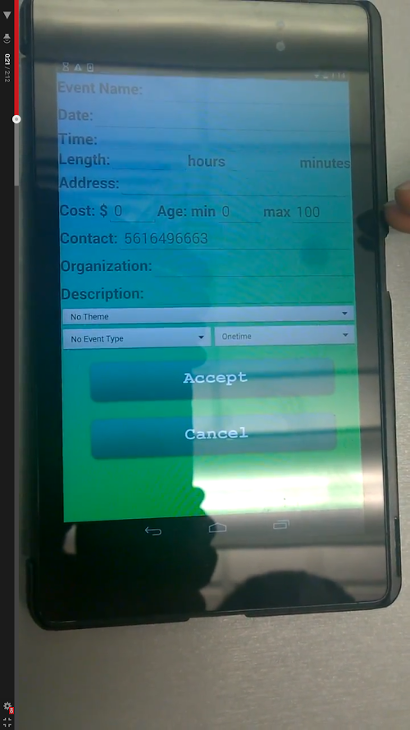

*An activity from the application: the ‘create event’ activity.*

**Methods**

*The methods our group used to accomplish the task of creating a basic application in*

*one week included collaboration both inside and outside of the classroom, and*

*communication via cell phones. We assisted each other and worked as diligently as*

*possible in the time allotted to us in class; it was a slow effort due to our limited*

*knowledge and familiarity with application development, but through efficient work*

*we were able to complete a basic application in one week.*

*Primary Java Methods:*

*onCreate()*

*onClick()*

*onCreateOptionsMenu()*

*onOptionsItemSelected()*

*onCreateView()*

*onItemSelected()*

*onAttach()*

*onDetach()*

*onListItemClick()*

*onSaveInstanceState()*

*setActivateOnItemClick()*

*takePhoto()*

*onActivityResult()*

**Results**

By the end of our class our app was, and still is, in the development stage. In the home screen the app loads to 4 buttons which all direct the user to a new page when tapped. The ‘create event’ button sends the user to a page with all the fields necessary to create an event. The ‘my events’ button leads the user to a field that consists of two sides. The first side displays the different events by name. The second side displays the event info of the currently selected event. The app does not currently store any events that are created and cannot display them in the ‘My Events’ tab. The next button is the ‘sign in’ button. Here, the user would enter an email with an optional password. Here it does a quick check in the local device to check if the user entered an email with an @. From this screen the user could also take a picture using the app and it would be stored in the temporary device memory. This was intended as the profile picture of the event. The last button was the ‘about’ button that would send the user to a page with information about the app, the mission statement, and the creator’s names.

**Discussion**

Overall, we think that the app at this point was relatively successful. The coding and graphics in the home screen and in the ‘about’ page were complete. More designs were originally planned to be implemented but, as a result of technical issues combined with lack of time, could not be implemented. Two key features that were not implemented that we planned was the ‘my events’ page and improvements to the ‘sign in’ page.

The ‘my events’ page was the biggest key feature that was not implemented. Currently the app shows sample events in both side of the screen. If we had laid out the ‘my events’ screen the way we wanted it, the layout would have had a color scheme of green and blue matching the rest of the app. The biggest improvement to this page would be that events created in the create event page would be transferred to the ‘my events’ page. Afterwards all the events we create would then be saved there.

The ‘sign in’ page worked as well, but it did not have all the features we wanted. When complete, the login page would have more information fields to fill out, such as name, age etc. Also the one other feature of the sign in page would be to change the camera button so that the extra page needed to open the camera would not be necessary. The sign in page’s use was to, in theory, have contact info to inform participants of the event of any information necessary. If the app was connected to a server, the app would notify the user of any event changes. So ultimately we wanted the app to connect to a server to share events and any changes in information.

**Conclusions**

Global Outreach was a great app to create. Even though not everything we wanted the app to do was applicable at the time, we learned a lot while creating it. If completed, the app could have been very useful. Throughout the time period we were given, the app went under rapid development to a point of almost completion. If we had implemented the remaining features we did not have time to, the app would have been complete and successful. Throughout this process we learned a lot about coding apps, making visual graphics and sharing ideas. If more time could be put into creating the app then the app would have shown all the features that we talked about earlier.

3-014 is the phone to use for the app

References

Newell, Mike. "Android 102 - Simple Android Camera Application." *YouTube*. YouTube, 28 July 2013. Web. 25 June 2015. (link) https://www.youtube.com/watch?v=k-3zXb7GteU